` Shivam Bhat

PUID: 0033760929

[bhat41@purdue.edu](mailto:bhat41@purdue.edu)

***Instructions***

**‘q1’ has question Q1 code - main3.py**

**‘q2’ has question Q2 code - main.py**

To run question

python main3.py --qn <Question Number>

For Q1.1

python main3.py --qn 1.1

For Q1.2

python main3.py --qn 1.2

For Q1.3

python main3.py --qn 1.3

For Q1.4

python main3.py --qn 1.4

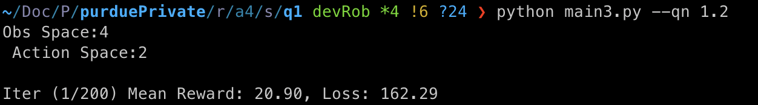

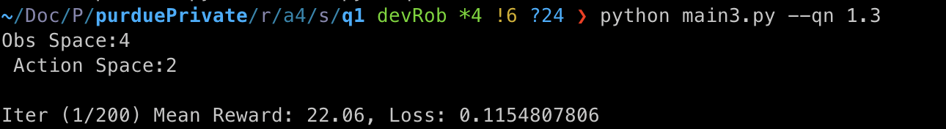

**Q2**

**Flags - ‘mode’- 0/1 and ‘modelPath’**

**mode - 1/0 - Test/Train if you want to train the model**

parser.add_argument('--mode', help='1/0 - Test/Train if you want to train the model')

parser.add_argument("--modelPath", help='defaults to \'./q2Model.pkl\'', default='./ModelPolicy.pkl')

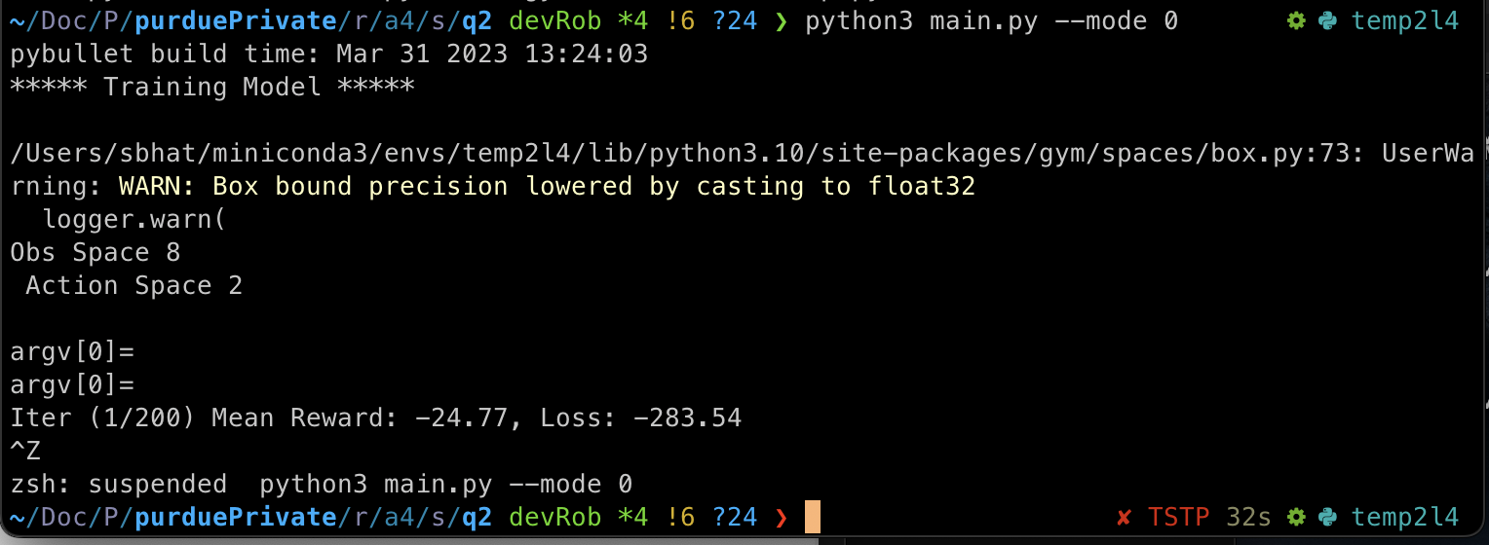

***OUTPUTS***

**Q1.1**:

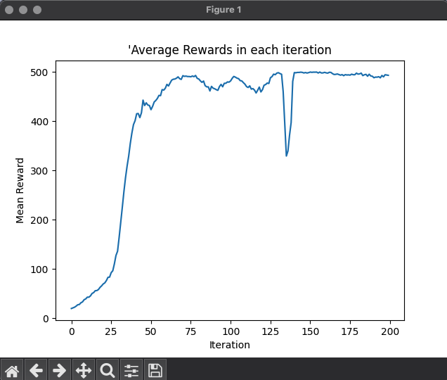

**Q1.2**:

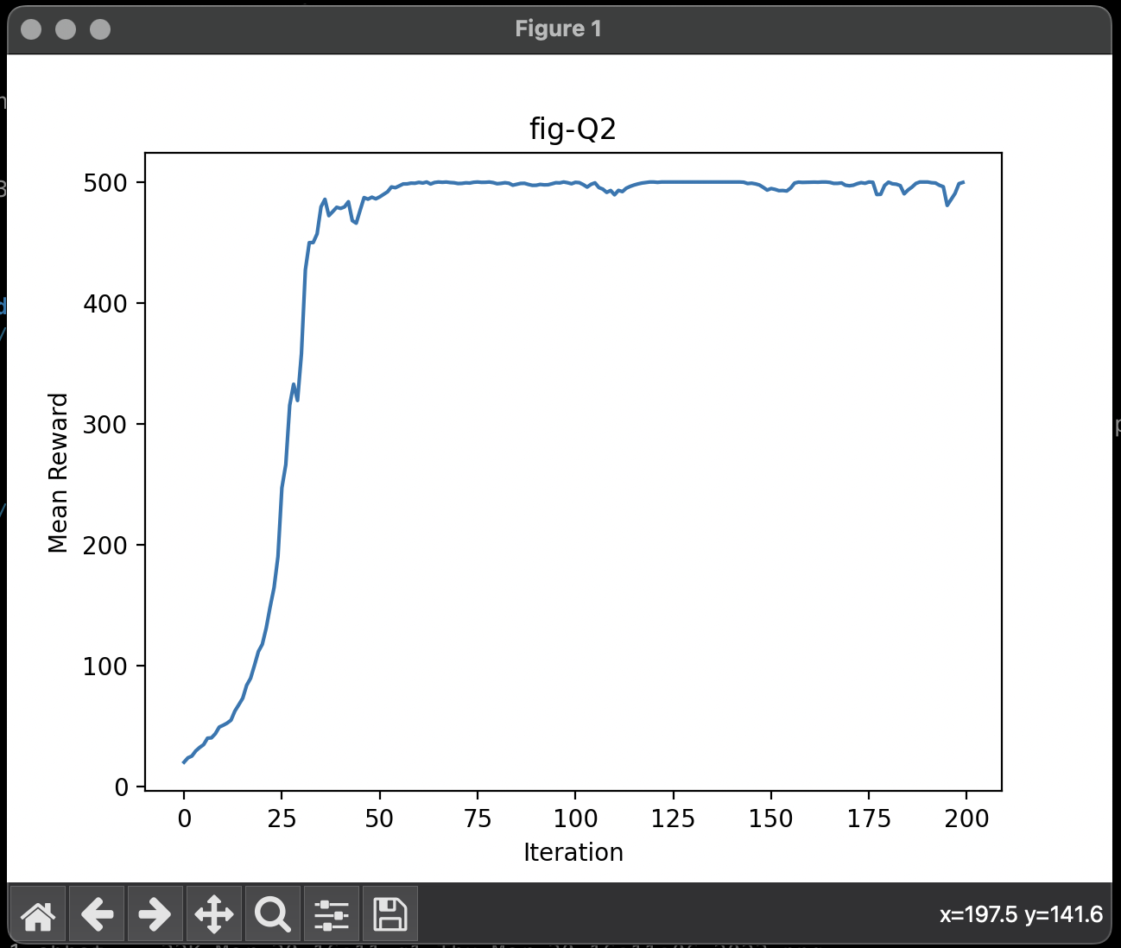

As expected on using discounted rewards the graph is smoother and consistent.

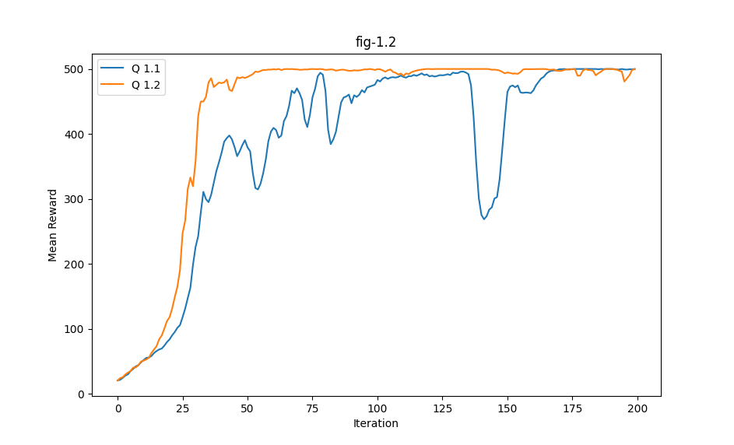

**Q 1.3**

**EP 500**

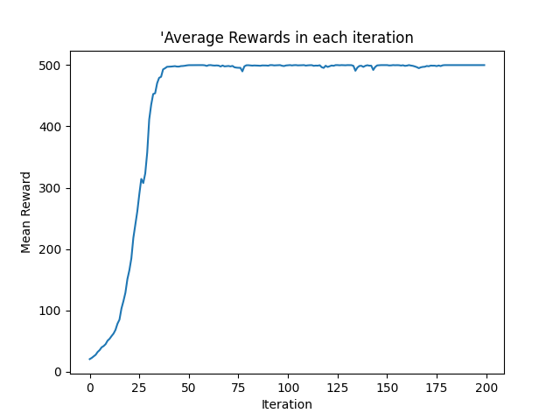

**The Results here show a steeper and smoother graph than that of Q1.1 and Q1.2. Here the graph rises (model learns) faster than 1.1 and 1.2**

**This is expected since we are normalising the future rewards.**

**Q 1.4**

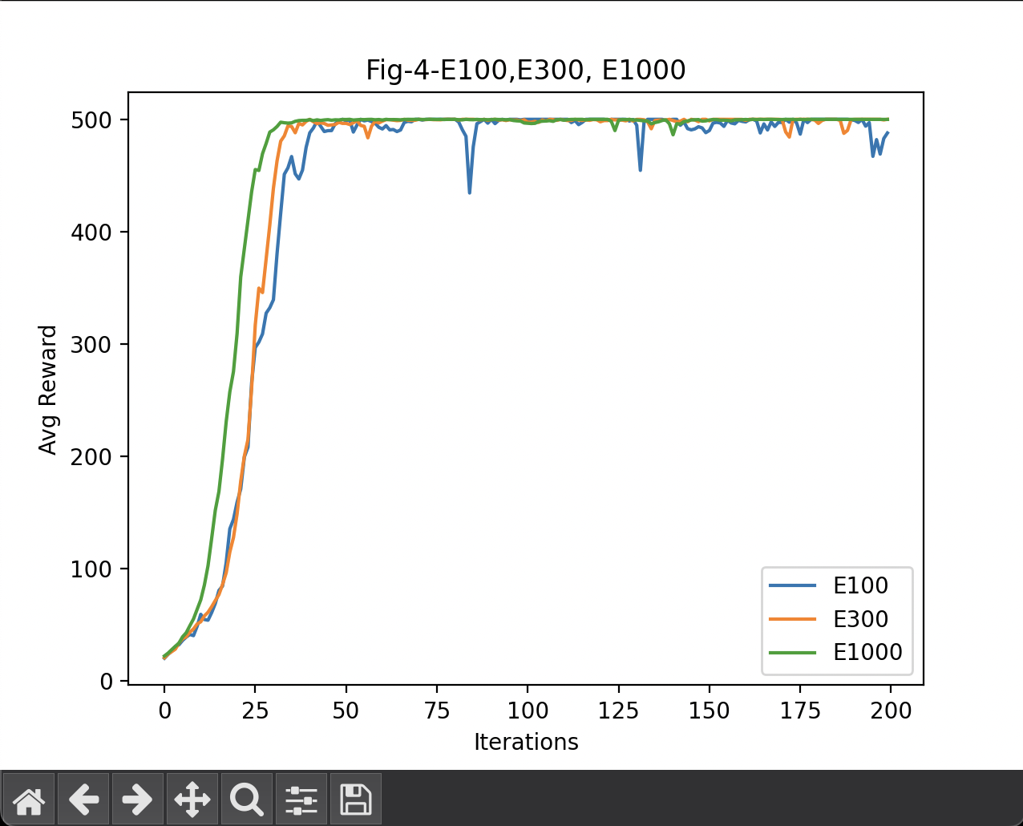

**Does increasing the episode count improve training?**

On increasing the episodes the model stabilises early and reaches good rewards early. Its able to perform better and learn quickly at a lower iteration count

**EP 100**

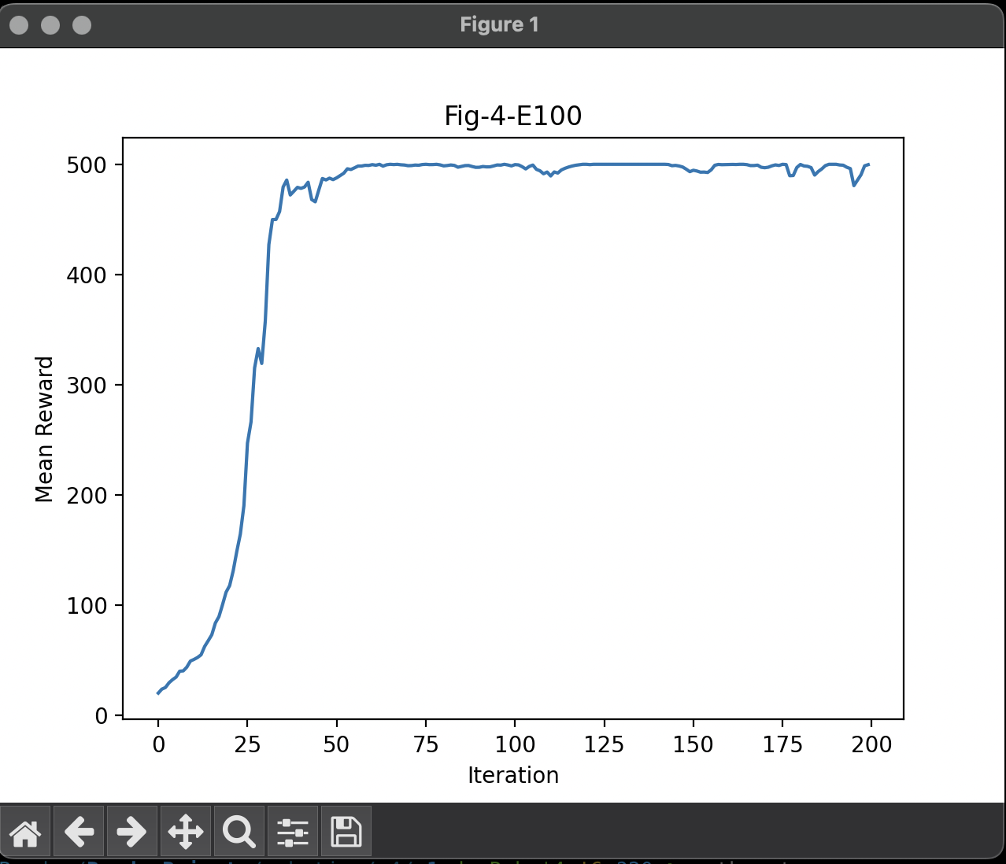

**E300**

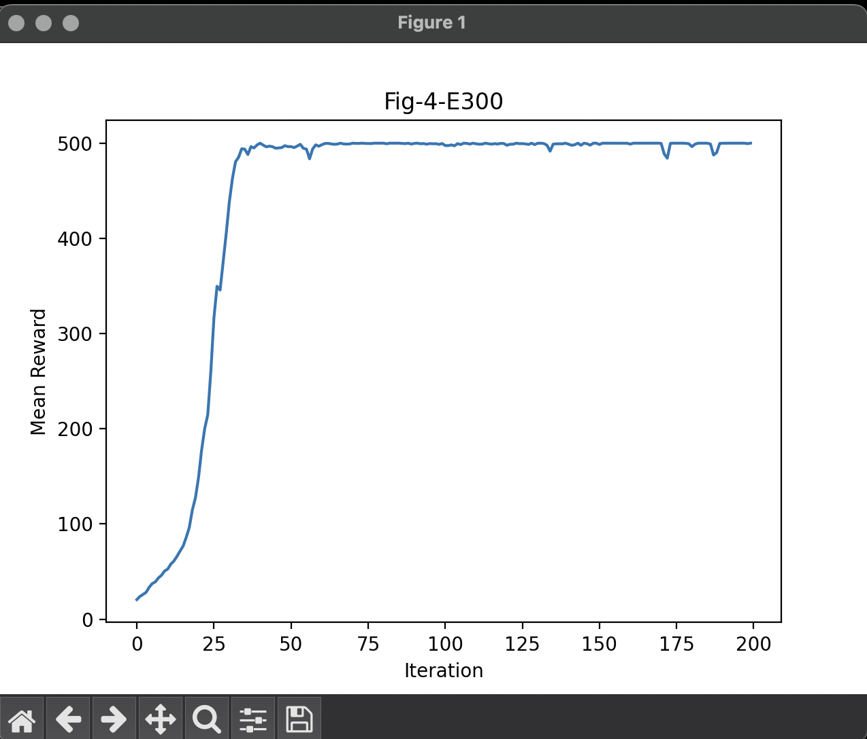

**EP 1000**

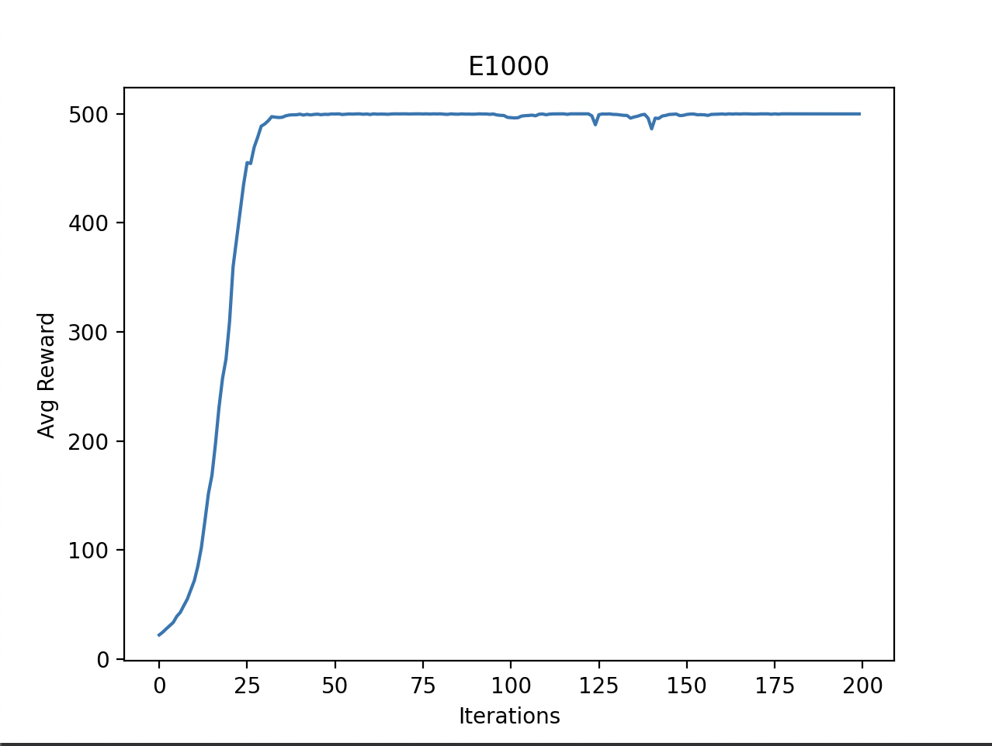

**Q2**

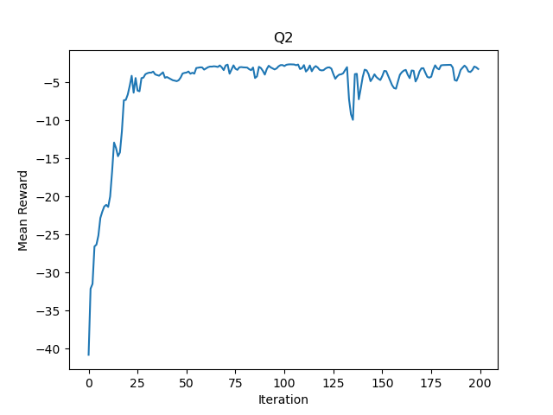



**I ran it for 200 iterations 500 episodes to get the best reward graph with loss reaching the required threshold of -3.5 as mentioned in** [**https://piazza.com/class/lcoyhxjko165ul/post/112**](https://piazza.com/class/lcoyhxjko165ul/post/112) **.**

**I used my Q 1.2’s policy since Q1.3 was still a work in progress and was taking time, so I went with visualising using policy two to complete Q2.**

**With 300 episodes the model wasn’t as accurate. But did cross -3.5 but was not as smooth**

**If I run it with more iterations=2000 then episodes came down ~ 64. However the question did not state the iteration count so I went with 200 only.**